2017 CCCFA State Championship - Impromptu - Round 1 Topics - SPEAKER 1
People would be surprised to know how much I learned about prayer from playing poker. -- Mary Hunter Austin
What really matters is what you do with what you have. -- H. G. Wells
No man really knows about other human beings. The best he can do is to suppose that they are like himself.
-- John Steinbeck

2017 CCCFA State Championship - Impromptu - Round 1 Topics - SPEAKER 2
No man can be stronger than his destiny. -- Mary Hunter Austin
Nothing ever fatigues me but doing what I do not like. -- Jane Austen
The proper function of man is to live, not to exist. I shall not waste my days in trying to prolong them. I shall use my time. -- Jack London

2017 CCCFA State Championship - Impromptu - Round 1 Topics - SPEAKER 3
I would rather be a superb meteor, every atom of me in magnificent glow, than a sleepy and permanent planet.
-- Jack London
Try to be a rainbow in someone's cloud. -- Maya Angelou
I get angry about things, then go on and work. -- Toni Morrison

2017 CCCFA State Championship - Impromptu - Round 1 Topics - SPEAKER 4
Life is not always a matter of holding good cards, but sometimes, playing a poor hand well. -- Jack London
The crisis of today is the joke of tomorrow. -- H. G. Wells
I do not want people to be very agreeable, as it saves me the trouble of liking them a great deal.
-- Jane Austen

2017 CCCFA State Championship - Impromptu - Round 1 Topics - SPEAKER 5
History is a race between education and catastrophe. -- H. G. Wells
What is right to be done cannot be done too soon. -- Jane Austen
No one wants advice - only corroboration. -- John Steinbeck

2017 CCCFA State Championship - Impromptu - Round 1 Topics - SPEAKER 6
Where an opinion is general, it is usually correct. -- Jane Austen
Virtue can only flourish among equals. -- Mary Wollstonecraft
We may encounter many defeats but we must not be defeated. -- Maya Angelou

2017 CCCFA State Championship - Impromptu - Round 1 Topics - SPEAKER 7
It is very difficult for the prosperous to be humble. -- Jane Austen
The path of least resistance is the path of the loser. -- H. G. Wells
When there is pain, there are no words. All pain is the same. -- Toni Morrison

2017 CCCFA State Championship - Impromptu - Round 2 Topics - SPEAKER 1
If you're not ready to die for it, put the word 'freedom' out of your vocabulary. -- Malcolm X
It always seems impossible until it's done. -- Nelson Mandela
My humanity is bound up in yours, for we can only be human together. —Desmond Tutu

2017 CCCFA State Championship - Impromptu - Round 2 Topics - SPEAKER 2
If you don't stand for something you will fall for anything. -- Malcolm X
You have to be taught to be second class; you're not born that way. -- Lena Horne
If there is no struggle, there is no progress. —Frederick Douglass

2017 CCCFA State Championship - Impromptu - Round 2 Topics - SPEAKER 3
The greatest glory in living lies not in never falling, but in rising every time we fall. -- Nelson Mandela
Never be limited by other people’s limited imaginations. —Dr. Mae Jemison
The time is always right to do what is right. —Dr. Martin Luther King, Jr.

2017 CCCFA State Championship - Impromptu - Round 2 Topics - SPEAKER 4
The only tired I was, was tired of giving in. -- Rosa Parks
After climbing a great hill, one only finds that there are many more hills to climb. -- Nelson Mandela
Have a vision. Be demanding. —Colin Powell

2017 CCCFA State Championship - Impromptu - Round 2 Topics - SPEAKER 5
Each person must live their life as a model for others. -- Rosa Parks
The cost of liberty is less than the price of repression. —W.E.B. Du Bois
Success is to be measured not so much by the position that one has reached in life as by the obstacles which he has overcome while trying to succeed. —Booker T. Washington

2017 CCCFA State Championship - Impromptu - Round 2 Topics - SPEAKER 6
Memories of our lives, of our works and our deeds will continue in others. -- Rosa Parks
In recognizing the humanity of our fellow beings, we pay ourselves the highest tribute. —Thurgood Marshall
We all have dreams. In order to make dreams come into reality, it takes an awful lot of determination, dedication, self-discipline and effort. —Jesse Owens

2017 CCCFA State Championship - Impromptu - Round 2 Topics - SPEAKER 7
Education is the passport to the future, for tomorrow belongs to those who prepare for it today. -- Malcolm X
Hate is too great a burden to bear. It injures the hater more than it injures the hated. —Coretta Scott King
Freedom is never given; it is won. —A. Philip Randolph

2017 CCCFA State Championship - Impromptu - Round 3 Topics - SPEAKER 1
“Would I rather be feared or loved? Easy. Both. I want people to be afraid of how much they love me.” -- Michael Scott, The Office
“I didn’t tell a soul, and they all promised to keep it a secret” – Lucy Ricardo, I Love Lucy
"Come on down!" - Price is Right

2017 CCCFA State Championship - Impromptu - Round 3 Topics - SPEAKER 2
“And I knew exactly what to do. But in a much more real sense, I had no idea what to do.” -- Michael Scott, The Office
“I may not be able to understand what you say when you say it, but before you say it, I can understand what you’re going to say perfectly!” – Lucy Ricardo, I Love Lucy
"You're fired!" — Donald Trump, The Apprentice

2017 CCCFA State Championship - Impromptu - Round 3 Topics - SPEAKER 3
“Sometimes I’ll start a sentence and I don’t even know where it’s going. I just hope I find it along the way.” -- Michael Scott, The Office
”Lucy, you got some ‘splainin’ to do!” – Ricky Ricardo, I Love Lucy
"Make it work." — Tim Gunn, Project Runway

2017 CCCFA State Championship - Impromptu - Round 3 Topics - SPEAKER 4
“I am Beyoncé, always.” -- Michael Scott, The Office
"D'oh!" - Homer Simpson, The Simpsons
"Everybody lies." — House, House

2017 CCCFA State Championship - Impromptu - Round 3 Topics - SPEAKER 5
“I am running away from my responsibilities. And it feels good.” -- Michael Scott, The Office
“Lucy! Im home!” - – Ricky Ricardo, I Love Lucy
"It's a good thing." — Martha Stewart, Martha Stewart Living

2017 CCCFA State Championship - Impromptu - Round 3 Topics - SPEAKER 6
“I’m an early bird and I’m a night owl. So I’m wise and I have worms.” -- Michael Scott, The Office
“"Yada, yada, yada." -- Jerry Seinfeld, Seinfeld
"Clear eyes, full hearts, can't lose." — Friday Night Lights

2017 CCCFA State Championship - Impromptu - Round 3 Topics - SPEAKER 7
“I love my employees even though I hit one of you with my car.” -- Michael Scott, The Office
"How you doin'?" Joey Tribbiani, Friends
"We've got a situation." — Mike "the Situation" Sorrentino, Jersey Shore

2017 CCCFA State Championship - Impromptu - FINAL ROUND Tweets - SPEAKER 1
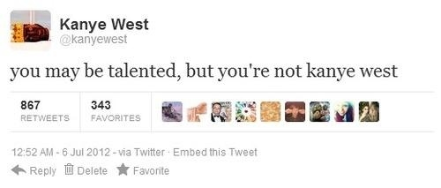

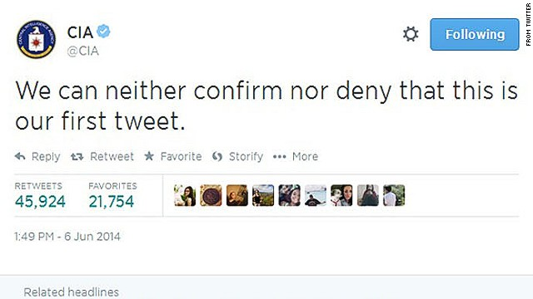
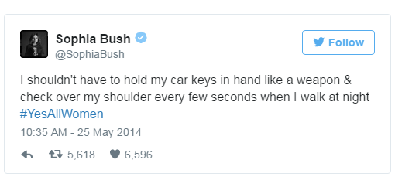

2017 CCCFA State Championship - Impromptu - FINAL ROUND Topics - SPEAKER 2
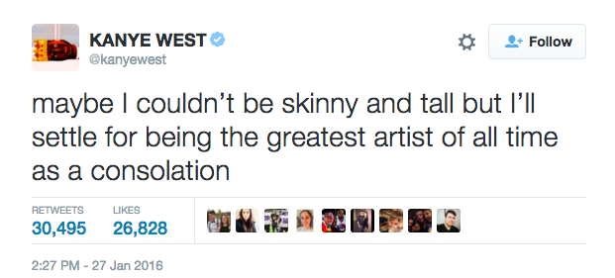

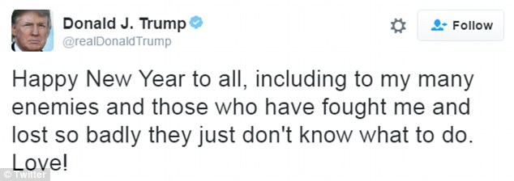

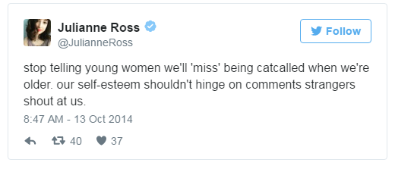

2017 CCCFA State Championship - Impromptu - FINAL ROUND Topics - SPEAKER 3
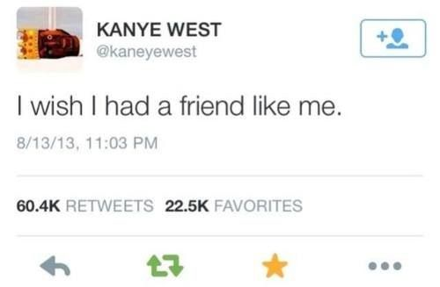

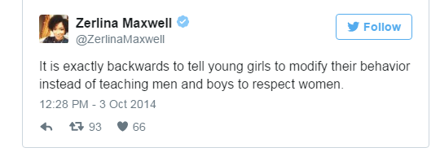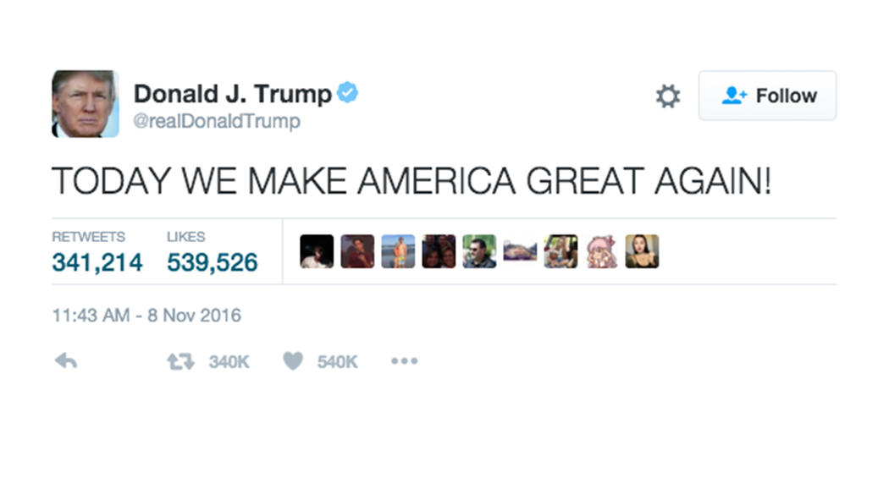

2017 CCCFA State Championship - Impromptu - FINAL ROUND Topics - SPEAKER 4
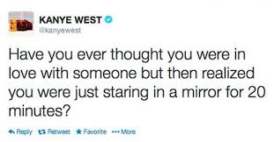
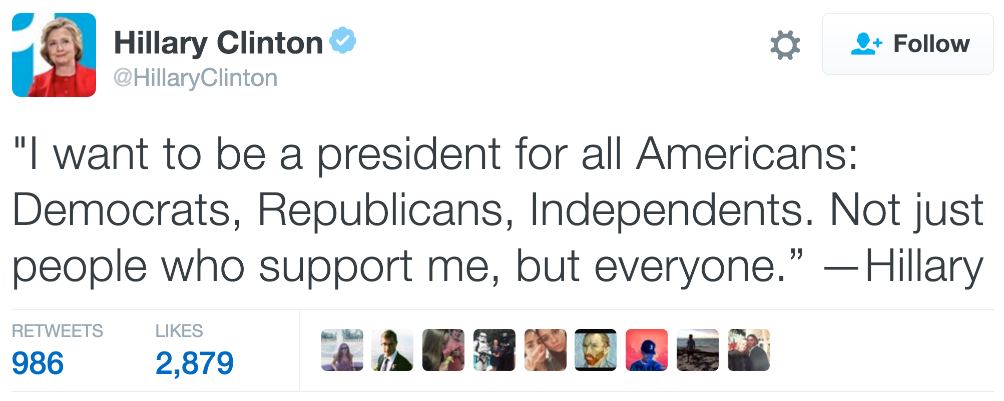
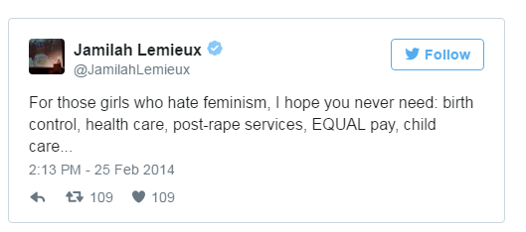

2017 CCCFA State Championship - Impromptu - FINAL ROUND Topics - SPEAKER 5
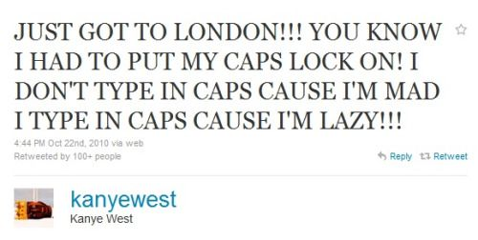
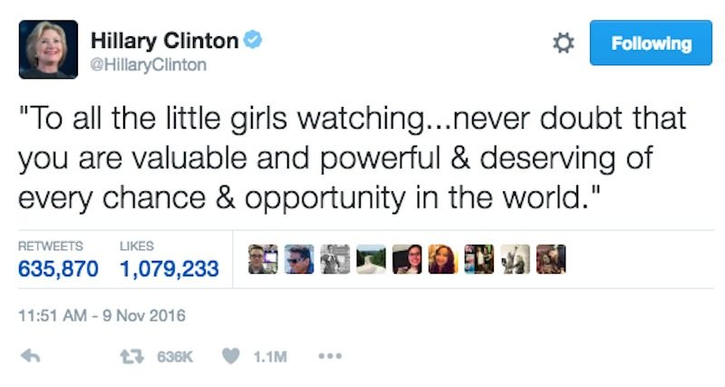

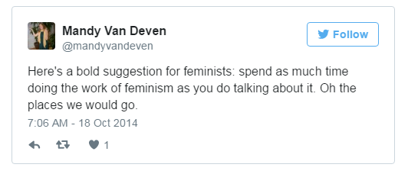

2017 CCCFA State Championship - Impromptu - FINAL ROUND Topics - SPEAKER 6
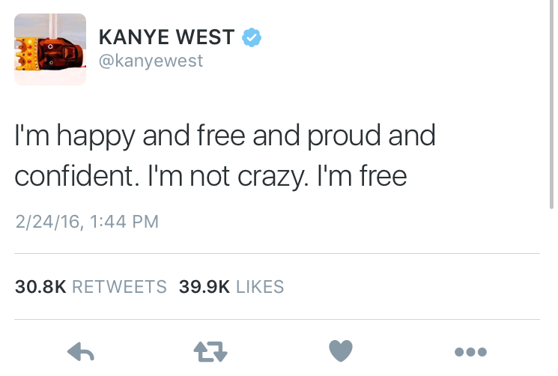
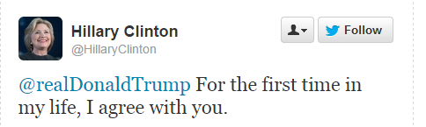

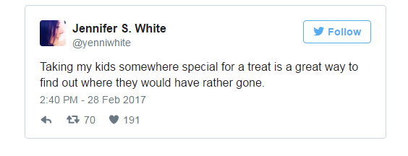

2017 CCCFA State Championship - Impromptu - FINAL ROUND Topics - SPEAKER 7

