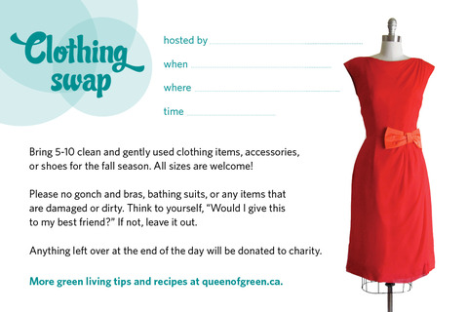
1st Annual Speech & Debate

Sam Barlow Speech and Debate Team

October 5, 2013

Sam Barlow Auditorium Hallway
9-4 pm

Ladies and Gentlemen:

Bring your clean and gently used tournament attire, accessories, and/or shoes to the Sam Barlow Invitational October 5, 2013. All sizes welcome!

Please no intimate apparel, nylons, or any items, that are damaged or dirty. Think to yourself, "Would I give this to my best friend?" If not, leave it out.

Bring your clothing to the Barlow Auditorium hallway by 8:30 AM on October 5. When you donate 5 clothing items, you will get a ticket stub to come back and shop for free between 9-4 that day. 7 item limit per ticket.

If you are not donating anything, you may buy a ticket at the tournament for $5.00 that allows you to select 6 clothing items in your size.

Anything left over at the end of the day will be donated to charity.

