

The Second Annual
Marist “Spartan Speaks”
Speech and Debate Tournament
January 24, 2015

WELCOME TO MARIST CATHOLIC HIGH SCHOOL AND THE SECOND ANNUAL “SPARTAN SPEAKS” TOURNAMENT!

We invite you to spend a day in Eugene, Oregon bordering the scenic Willamette River and enjoying the Marist campus.
The tournament will be held Saturday January 24, 2015. We offer CX, LD, Parliamentary, and Public Forum Debate. We will also offer all State individual events, plus our own “bonus event” that has not been offered previously in Oregon, in this format.
PLEASE NOTE: Also due to the size of our facility, we are unable to offer a novice division for this tournament. We apologize to those looking for that extra novice tournament, but we simply don’t have the space to house that many competition rooms simultaneously.
Trophies/plaques will be given out to 1st, 2nd, and 3rd place teams/competitors as well as outstanding individual speakers in debate. Medals will be given out to finals qualifiers. We also plan to offer Sweepstakes Awards to the top 3 schools.

REGISTRATION:
- Please enter online at: http://www.forensicstournament.net/index.php
- Registrations are due Tuesday, January 20th at 4:00 pm.
- Changes to your registration will be accepted until 4:00 pm on Wednesday, January 21st. Fees will be assessed at that time.
- If you have drops after this day PLEASE email and let me know as last minute drops will cause a delayed start to the tournament. Also, it is important to register early as we may fill up before the deadline.

PATTERNS:
- Pattern A: ADS, DI, Duo, Expos, Extemp, HI, Impromptu, Oratory, Poetry, Prose, Radio
- Pattern B: Public Forum, LD, Parliamentary, LIBELL, Creative Storytelling
- Pattern C: CX

BONUS EVENT: CREATIVE STORYTELLING
Creative Storytelling: Back in my high school speech days in Colorado, my favorite event was called Creative Storytelling. I have always been sad that this event was not offered in Oregon. So I have decided to offer it here in my own tournament, to see what people think. Here’s how it works: Think of the event like impromptu for Interpers. Each contestant will enter their competition room with their judge, just like impromptu. But instead of getting a slip of paper with topics to speak on, the competitor will receive a piece of paper with three things: A main character, a location, and some kind of action. The student then has 2 minutes to prepare a 5 minute story, complete with plot, story structure, narration, distinct characters, dialogue, and a life-lesson morale at the end. The goal is to be able to tell an engaging story, with beginning, middle and end, while entertaining your judge, using quality speaking skills. Competitors may use paper during the two-minute prep period for their own notes and organization, but may not use notes during the presentation of the speech.
Sample:
Character: Billy The Bunny
Location: Farmers Field
Action: Avoiding Farmer Bob’s gun after eating his carrots.

CONFLICTS:
- Students may enter 2 conflicting Individual Events per pattern at their own risk.

Entry Limitations:
First Come-First Served. If I see the registrations exceeding the space Marist has available, I will have to close registrations to prevent us from getting into a bad place. To help avoid this, I have put the following limits in place:
- Teams are limited to 12 debate entries TOTAL spread throughout all types of debate. For example, 1 Parli TEAM of 2 people counts as 1 debate entry. So if you registered 6 Parli teams, 3 PoFo teams, and 3 LD competitors, you would fill your tournament limit.
- Please limit IE entries to a maximum of 10 per event TOTAL. Please don’t register your entire 25-person team for impromptu.. :)

TOPICS:
LINCOLN-DOUGLAS VALUE DEBATE: We will use the 2015 January/Vebruary NFL Topic and use OSAA rules: Resolved: Just governments ought to require that employers pay a living wage.

PARLIAMENTARY DEBATE: We will use OSAA rules. Students may only use a dictionary to prepare their cases. 15 minutes prep. Students will prep in their competition rooms.

PUBLIC FORUM DEBATE: We will use OSAA rules. The 2015 January Public Forum Topic shall be used, which is: United Nations peacekeepers should have the power to engage in offensive operations.

JUDGES:
- One judge covers seven individual event entries or four debate entries. Each uncovered entry will be charged $10.00. Please bring judges as we want to have a smooth tournament and we would rather have the judges than the money.
- Please clearly state in your registration when your judges will be present. If your judges do not cover the whole day, you may be charged.
- Please also indicate who is “in charge” of your team if your head coach will not be present. Each school must have one experienced judge or head coach present the entire tournament.
- If your judges do not pick up their ballots, we reserve the right to bill your team.
- We use teachers, parents and community members to judge (especially in Parliamentary and Public Forum). Please advise your students that they will need to adapt.

TRAVEL AND DIRECTIONS:
The Marist Campus is located at 1900 Kingsley Road in Eugene OR.

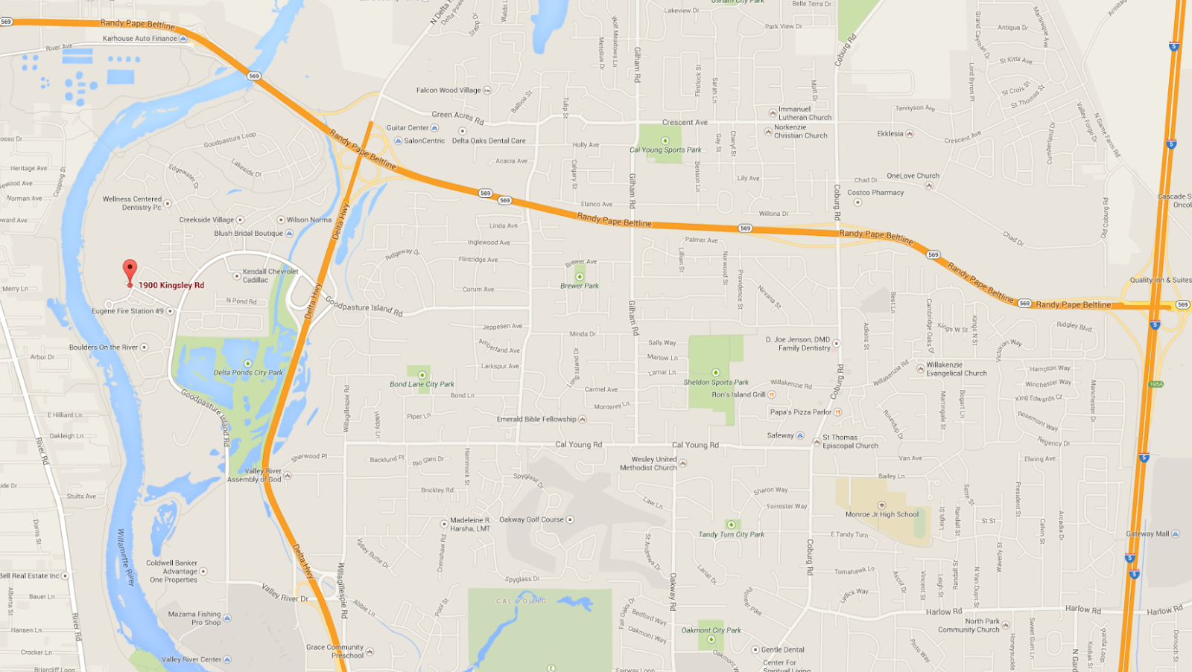

Coming From the South:
- Travel North on 1-5
- Take exit 194B to merge onto OR-126 W toward Eugene/I-105 W
- Drive 2.3 miles
- Take Exit 1 for Delta Highway toward Beltine Highway
- Merge onto Delta Highway
- Take first exit: Goodpasture Island Road
- At stoplight, turn left onto Goodpasture Island Road
- At second stoplight, turn right onto Kingsley Rd.
- Follow road all the way into Marist Campus.
- Signs will direct you into check-in area.

Coming From the North:

- Travel South on 1-5
- Take exit 194B to merge onto OR-126 W toward Eugene/I-105 W
- Drive 2.3 miles
- Take Exit 1 for Delta Highway toward Beltine Highway
- Merge onto Delta Highway
- Take first exit: Goodpasture Island Road
- At stoplight, turn left onto Goodpasture Island Road
- At second stoplight, turn right onto Kingsley Rd.
- Follow road all the way into Marist Campus.
- Signs will direct you into check-in area.

ENTRY FEES:
School Fee: $30.00
IE Entry: $4.00 per entry
Debate Entries (and Duo): $8.00 per team entry

FOOD:
Students: There is a Subway within a 10-minute walk from campus, and a number of eating options at the Valley River Center Mall (a 5-minute drive). On campus there are vending machines with typical fare, but the easiest solution is to have students bring food.

Coaches/Judges: We will also provide free meals for judges as well. (Ensure your judges they will be eating very well! If you attended our tournament last year.. you’ll know the amazingness of my judges/coaches food room!)

CONTACT FOR QUESTIONS:
Tournament Director: Steve Barth
Email: steve@stevebarth.com
Cell Phone: 541-214-4858 (call or text)

MARIST HIGH SCHOOL “SPARTAN SPEAKS” SPEECH AND DEBATE TOURNAMENT SCHEDULE

PATTERNS:
- Pattern A: ADS, DI, Duo, Expos, Extemp, HI, Impromptu, Oratory, Poetry, Prose, Radio
- Pattern B: Public Forum, LD, Parliamentary, LIBELL, Creative Storytelling
- Pattern C: CX

SCHEDULE:

7:00 - 7:40…..……………………….…..….......……………………………...……..…..Registration

7:40 - 7:55 …..……………………….…..……………..……..All Competitors Meeting in Cafeteria

7:45 …..……………………….…..…………………………………...………………... Extemp Draw

8:00 - 9:45…….…………………….………………………….…………….........…..Rd. 1 Pattern A

9:00 …….…………………….………………………….…………………...........…..Rd. 1 Pattern C

9:45 - 11:15….……………………….…………………………..……….......…….…Rd. 1 Pattern B

11:15 - 12:45….……………………….………………....Rd. 2 Pattern A - Draw Extemp 11:00 am

12:00….……………………….………......………………………………...…...….…Rd. 2 Pattern C

12:45 - 2:15……………………….………………...............................................…Rd. 2 Pattern B

2:15 - 3:45……………………………….…………….....Rd. 3 Pattern A - Draw Extemp 11:00 am

3:00 ……………………………….……........................................................…..…Rd. 3 Pattern C

3:45 - 5:15…………………………………….…...............................................…. Rd. 3 Pattern B

5:15 - 6:45…………………………….…….…...............................................….. Finals Pattern A
Draw Extemp 4:30pm

5:15/ASAP…………………………….…….………………….........................….. Finals Pattern C

6:00/ASAP ………………………………..............................................................Finals Pattern B

7:45 or ASAP ……………………………………………………………….......Awards in Cafeteria

