Greetings from Great Falls High, home of the Mighty Bison!

You are invited to our November 3rd One-Day Kick-Off Central Montana Regional Tournament/Stampede!

We will offer All AA Events (including POI and Legislative Speaking)
- Each team can bring four contestants per event, with a MAXIMUM of 35 ENTRIES PER SCHOOL (sorry for shouting)

Preliminary rounds will take place at 8:00AM, 10:00AM, and 12:00PM, with Semi-Final rounds at 2:00PM and Final rounds at 4:00.

Awards will take place at 6:00 in the auditorium . . .

Cost per entry is $5.00 per student/per entry (double-entered students pay $5.00 PER event)

REGISTRATION DUE DATES: Prelim numbers by October 19 and final registration by October 30

GFH is currently in the middle of construction! Parking is scarce and kids have to hike the Oregon Trail to get between buildings . . . we will do our best to keep all rounds in one building.

BUSSES can drop off students at the front doors on 20th Street and 3rd Avenue South, but may have to park in Belt . . . (Keith’s suggestion)

We will not offer concessions, but we will have a station of hot water and microwaves for the students. Students will park themselves in the cafeteria (in the basement).

We will have yummy vittles for the coaches . . .

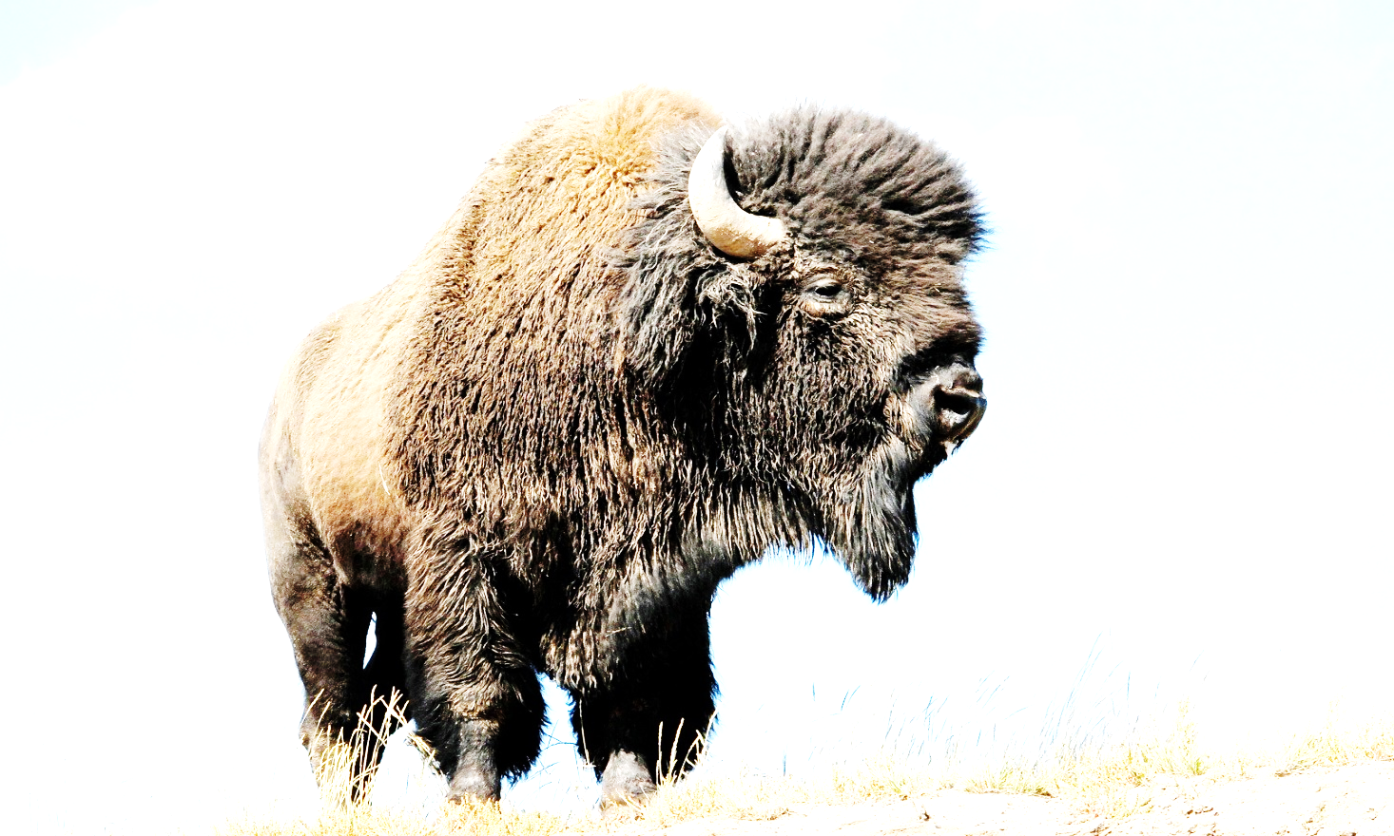
The TAB ROOM will be in the library on the second floor, and EXTEMP DRAW will begin at 7:30 in Room 112A and 112B.

Any questions, email Julie Easton at julie_easton@gfps.k12.mt.us

