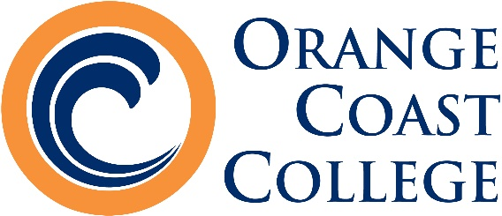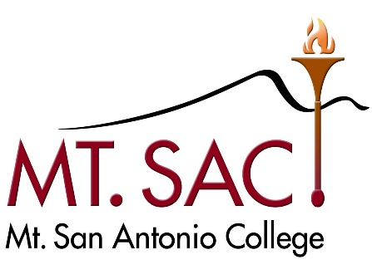

October 12, 2018

Dear Friends and Colleagues:

Orange Coast College and Mt. San Antonio College are pleased to invite you to Southern California for our 7th annual “Close to the Coast” swing tournament January 19-20, 2019. This year’s tournament will be held in Costa Mesa, CA on the beautiful campus of Orange Coast College. OCC and Mt. SAC have partnered up again to host this swing and give your teams an excellent January tournament in sunny* Southern California.

The two tournaments will offer similar schedules and fees. Both tournaments will have sweeps awards for the top three teams and top community college team. Both days will offer novice and open divisions in individual events and debate. We will award a top speaker of the swing tournament as well.

In addition to the individual events, we will host a one-day parliamentary debate tournament on Saturday and a one-day NFA-LD & IPDA debate tournament on Sunday. For both days the Open division will be a standard 4/2 format but in novice we will have a six prelim tournament with Gold/Silver/Bronze awards given to the top teams. NOTE: Students may not enter both debate and IE events on the same day. Students are more than welcome to mix and match on different days. OCC will be the official host on Saturday, and Mt. SAC will be the host on Sunday.

Don’t you wish you were Close to the Coast?! Join us for some great competition and even better memories. Our tab staff will be top notch so you can expect a well-run tournament. Let us know how we can help with your travel plans or anything else that will make this a special weekend for your team.

Hope to see you there!
The Coaching Staff at Orange Coast College and Mt. San Antonio College

*Beautiful weather likely but not guaranteed

Remember those amazing forensics pins from last season??
Come to the Close to the Coast tournament to add to your collection!



TOURNAMENT INFORMATION:
- Postings will be at the Literature and Language Building
- Because of the swap meet on campus no parking is available in the Adams Lot. We recommend that you park in Lot E off Merrimac Way.
- Please email OCC Coach Shaw Davari: sdavari@occ.cccd.edu for more information about the tournament.
- Triple entry at your own risk. No triple-entry with extemp or duo. Novices may not double-enter.
- Students from the host schools may compete both days, but will not be in the running for a team award the day their school is hosting.
- AFA event descriptions will apply. We will use AFA style for impromptu.

IE SCHEDULE/ENTRIES:
Pattern A: Persuasion, DI, POI, Impromptu, Duo, CA

Pattern B: Extemp, Informative, Prose, Poetry, ADS

Schedule (both days)
8:00 Registration (First floor, Literature & Languages Building)
8:30 Round 1A
9:45 Extemp Draw
10:00 Round 1B
11:15 Round 2A
12:30 Extemp Draw
12:45 Round 2B
2:00 Round 3A
3:15 Extemp Draw
3:30 Round 3B
5:00 Finals A
6:15 Ext Draw
6:30 Finals B
8:00 or TBA Awards

DEBATE SCHEDULE/ENTRIES:

Saturday: Parli (Novice & Open)  9:00-9:45: Registration (First floor, Literature & Languages Building) – Debaters must sign in.  10:00 Round 1  11:15 Round 2  12:45 Round 3  2:00 Round 4  3:30 Round 5  5:00 Bronze (Open) / Round 6 (Novice)  6:30 Gold (Open) / Round 7 (Novice)  8:00 or TBA Awards  Open division will have a bronze and gold round during novice division rounds 6 & 7. | Sunday: NFA-LD & IPDA (Novice & Open)  9:00-9:45: Registration (First floor, Literature & Languages Building) – Debaters must sign in.  10:00 Round 1  11:15 Round 2  12:45 Round 3  2:00 Round 4  3:30 Round 5  5:00 Bronze (Open) / Round 6 (Novice)  6:30 Gold (Open) / Round 7 (Novice)  8:00 or TBA Awards  Open division will have a bronze and gold round during novice division rounds 6 & 7.

- Parliamentary Debate will be run in accordance with Phi Rho Pi rules. We will use topic strikes with 15 minutes of preparation time. There will be no coaching during preparation time, and students will be allowed paper, dictionaries, almanacs and/or electronic research material. Brackets will be broken in Open division. Except for notes that the debaters themselves have prepared during preparation time, no published materials, prepared arguments, or resources may be used during the debate. We will not offer elimination rounds in novice in lieu of everyone in novice debating a seventh and eighth preliminary round. Awards will be based off preliminary rankings.
- This year elimination rounds will be in the Phi Rho Pi bronze/gold format. We will break an appropriate number of teams based on entry size (not to exceed half).
- No debate prep rooms will be made available. The government team may prepare in their competition room.
- Standard PSCFA definitions for novice debate eligibility will be used.
- We are excited to be adding IPDA this year for the Sunday tournament. Note that we will try to adhere to the goal of using lay judges in both divisions of IPDA. We will do central topic strikes for IPDA.

JUDGING:

All judges must be available for all rounds.
- Individual Events - One judge covers 5 total slots per pattern.
- Debate - One judge covers 2 entries. Uncovered Debate entries must be approved by the Tournament Director before the entry deadline.

FEES (per tournament):
All Entries MUST be received by 5:00pm PST Tuesday, January 15, 2019. Fees are computed at that time. We will use forensicstournament.net for all entries.

$20.00 | school fee
$ 8.00 | per IE slot
$12.00 | judging fee per uncovered IE slot
$20.00 | per Parli Debate Entry
$20.00 | per NFA-LD/IPDA Debate Entry
$50.00 | judging fee per uncovered debate entry
$15.00 | per change after Tuesday at 5pm
$100.00 | dropped judge fee after Thursday at 5pm

Checks MUST be made out to “Orange Coast College - Speech & Debate” for Saturday’s tournament and “Mt. SAC Speakers” for Sunday’s tournament. Because of the very specific rules of our respective institutions, each school that pays by check must provide a separate check, made out to the specific host school, for each day of the swing.

TRAVEL INFO:

Orange Coast College is located in Costa Mesa, CA at

2701 Fairview Road, Costa Mesa CA 92626.

The Ontario airport is roughly 40 minutes away.
The Long Beach airport is about 30 minutes away.
LAX is roughly 45-50 minutes away.
John Wayne/OC airport is 15 minutes away.
Directions from the 405 (San Diego) Freeway:
- In Costa Mesa, exit Harbor Boulevard, going south.
- Proceed South on Harbor for just over ¾ of a mile to Merrimac Way.
- Turn left (East) on Merrimac.
- Orange Coast College is now on your left.
- Turn left into Parking Lot E off of Merrimac. Parking is free on weekends.
http://www.orangecoastcollege.edu/about_occ/Pages/Map-and-Directions.aspx

HOTEL OPTIONS:

Hilton Costa Mesa
3050 Bristol Street
Costa Mesa, CA. 92626
(855)271-3621

Best Western Inn & Suites Costa Mesa
2642 Newport Blvd.
Costa Mesa, CA. 92627
(800)568-8520

Vagabond Inn
8205 Harbor Blvd.
Costa Mesa, CA. 92626
(800)43-HOTEL
(714)557-8360

We’re looking forward to seeing you in January.
Please let us know if you have any questions!

